**SHORT STRADDLE**

**This material is from** [**Zerodha Varsity**](https://zerodha.com/varsity/chapter/the-short-straddle/)

## 11.2 – The Short Straddle

Although many traders fear the short straddle (as losses are uncapped), I personally prefer trading the short straddle on certain occasions over its peer strategies. Anyway let us quickly understand the setup of a short straddle, and how its P&L behaves across various scenarios.

Setting up a short straddle is quite straight forward – as opposed to buying the ATM Call and Put options (like in long straddle) you just have to sell the ATM Call and Put option. Obviously, the short strategy is set up for a net credit, as when you sell the ATM options, you receive the premium in your account.

Here is an example, consider Nifty is at 7589, so this would make the 7600 strike ATM. The option premiums are as follows –

* 7600 CE is trading at 77
* 7600 PE is trading at 88

So the short straddle will require us to sell both these options and collect the net premium of 77 + 88 = 165.

Please do note – the options should belong to the same underlying, same expiry, and of course same strike. So assuming you have executed this short straddle, let’s figure out the P&L at various market expiry scenarios.

**Scenario 1 – Market expires at 7200 (we lose money on put option)**

This is a scenario where the loss in the put option is so large that it eats away the premium collected by both the CE and PE, resulting in an overall loss. At 7200 –

* 7600 CE will expire worthless; hence we get the retain the premium received i.e. **77**
* 7600 PE will have an intrinsic value of 400. After adjusting for the premium received i.e. Rs.88, we lose 400 – 88 = **– 312**
* The net loss would be 312 – 77 = **– 235**

As you can see, the gain in call option is offset by the loss in the put option.

**Scenario 2 – Market expires at 7435 (lower breakdown)**

This is a situation where the strategy neither makes money nor loses any money.

* 7600 CE would expire worthless; hence the premium received is retained. Profit here is Rs.77
* 7600 PE would have an intrinsic value of 165, out of which we have received Rs.88 as premium, hence our loss would be 165 – 88 = **-77**
* The gain in the call option is completely offset by the loss in the put option. Hence we neither make money nor lose money at 7435.

**Scenario 3 – Market expires at 7600 (at the ATM strike, maximum profit)**

This is the most favorable outcome for a short straddle. At 7600, the situation is quite straight forward as both the call and put option would expire worthless and hence the premium received from both the call and put option will be retained. The gain here would be equivalent to the net premium received i.e Rs.165.

So this means, in a short straddle you make maximum money when the markets don’t move!

**Scenario 4 – Market expires at 7765 (upper breakdown)**

This is similar to the 2nd scenario we discussed. This is a point at which the strategy breaks even at a point higher than the ATM strike.

* 7600 CE would have an intrinsic value of 165, hence after adjusting for the premium received of Rs. 77, we stand to lose Rs.88 (165 – 77)
* 7600 PE would expire worthless, hence the premium received i.e Rs.88 is retained
* The gain made in the 7600 PE is offset against the loss on the 7600 CE, hence we neither make money nor lose money.

Clearly this is the upper breakdown point.

**Scenario 5 – Market expires at 8000 (we lose money on call option)**

Clearly the market in this scenario is way above the 7600 ATM mark. The call option premium would swell, so would the loss –

* 7600 PE will expire worthless, hence the premium received i.e Rs.88 is retained
* At 8000, the 7600 CE will have an intrinsic value of 400, hence after adjusting for the premium received of Rs. 77, we stand to lose Rs. 323(400 -77)
* We have received Rs.88 as premium for the Put option, therefore the loss would be 88- 323 = **-235**

So as you can see, the loss in the call option is significant enough to offset the combined premiums received.

Here is the payoff table at different market expiry levels.

[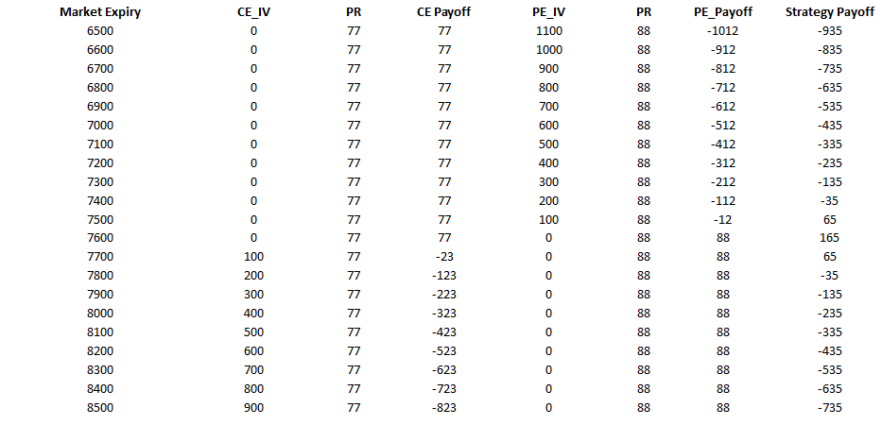](http://zerodha.com/varsity/wp-content/uploads/2016/04/Image-1_payoff.png)

As you can observe –

1. The maximum profit 165 occurs at 7600, which is the ATM strike
2. The strategy remains profitable only between the lower and higher breakdown numbers
3. The losses are unlimited in either direction of the market

We can visualize these points in the payoff structure here –

[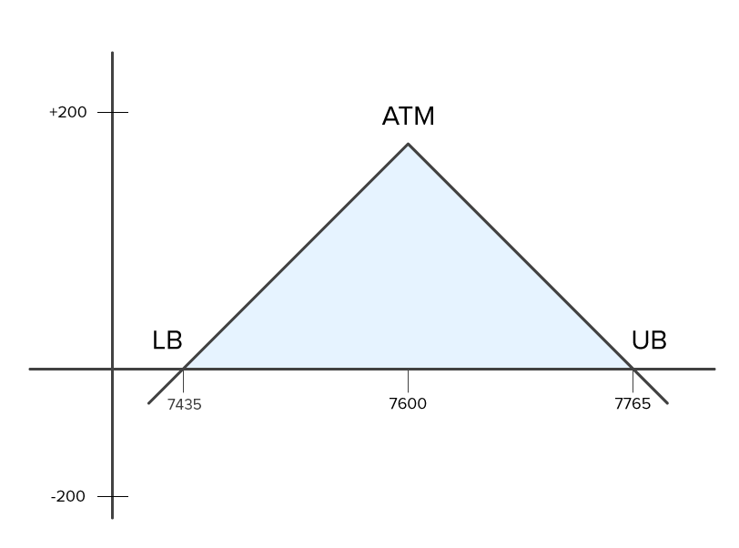](http://zerodha.com/varsity/wp-content/uploads/2016/04/Image-2_payoff-chart.png)

From the inverted V shaped payoff graph, the following things are quite clear –

1. The point at which you can experience maximum profits is at ATM, the profits shrink as you move away from the ATM mark
2. The strategy is profitable as long as the market stays within the breakdown points
3. Maximum loss is experienced when markets move further away from the breakdown point. The further away the market moves from the breakdown point, higher the loss
   1. Max loss = Unlimited
4. There are two breakdown points – on either side, equidistant from ATM
   1. Upper Breakdown = ATM + Net premium
   2. Lower Breakdown = ATM – Net premium

As you may have realized by now, the short straddle works exactly opposite to the long straddle. Short straddle works best when markets are expected to be in a range and not really expected to make a large move.

Many traders fear short straddle considering the fact that short straddles have unlimited losses on either side. However from my experience, short straddles work really well if you know how exactly to deploy this. In fact in the last chapter of the previous module, I had posted a case study involving short straddle. Probably that was one of the best examples of when to implement the short straddle.

I will repost the same again here and I hope you will be able to appreciate the case study better.